Task-1 Draw a labelled diagram of a typical home WiFi router and a network switch, clearly marking at least 3 different ports (such as WAN, LAN, Console) and the location of status LEDs.
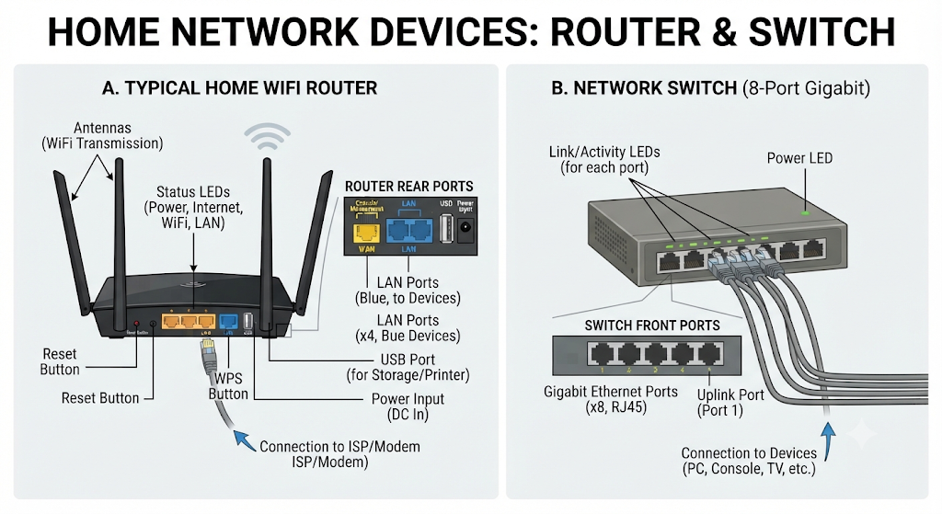

Task-2 List 3 key differences between routers and switches in terms of their main functions and how they handle network traffic.Hint:Think about how each device deals with IP addresses, MAC addresses, and the types of networks they connect.</em>

1. Types of Networks Connected (Scope)
- Router: Connects different networks together—most commonly bridging your private local area network (LAN) to the public wide area network (WAN/Internet).

- Switch: Connects multiple devices together within a single local network (LAN), creating a localized communication hub for computers, printers, and consoles.

2. Network Addressing (IP vs. MAC Addresses)
- Router: Operates using IP addresses (Layer 3) to identify devices across distinct networks and determine the best path for data to travel across the globe.

- Switch: Operates using physical MAC addresses (Layer 2) to identify specific hardware devices connected to its ports, ignoring network boundaries.

3. Traffic Handling and Forwarding Method
- Router: Inspects incoming data packets, consults a routing table, performs Network Address Translation (NAT), and actively routes traffic from one network to another.

- Switch: Uses an internal MAC address table to examine incoming Ethernet frames and forward them directly from the source port to the specific destination port without altering packet headers.

Task-3 Take a real or virtual image of a router and a switch (from your home, lab, or Google Images), and identify the following on each: Power port, at least 2 Ethernet ports, and any LED indicators. Annotate the image or describe their position and purpose.
Here are annotated images of a typical home router and an unmanaged network switch, with the requested components clearly identified.

1. Wireless Router (Back View)
The router is the device that manages your home network and connects it to the internet via a modem. Most of the key ports are located on the back.

Image Annotations:

- A. Power Port (DC In): This is the circular port where the included AC power adapter plugs in to provide electrical power to the router.

- B. Internet (WAN) Port (Blue): This Wide Area Network port connects via an Ethernet cable to your modem. This is the source of your internet connection from your Internet Service Provider (ISP).

- C. Ethernet LAN Ports (Yellow): These Local Area Network ports are used to create wired connections to devices within your home, such as a desktop computer, game console, or smart TV. This router has four yellow LAN ports.

- D. USB Port: While not requested, this is common for connecting external storage or printers.

- E. Status LED Indicators (Visible on top edge): Although these are often on the front, some indicator lights (like Power, Internet, Wi-Fi status) are visible along the top edge here.

2. Network Switch (Front View)
A network switch simply expands the number of available Ethernet ports on your network. It is a much simpler device, typically with all ports and indicators on the front.

Image Annotations:

- F. Power LED Indicator: This single light confirms that the switch is powered on and functioning.

- G. Multiple Ethernet Ports: This switch has 8 identical RJ45 ports. Every port can be used to connect any combination of devices (computers, printers) or to connect the switch to your main router (using one of the ports as an "uplink").

- H. Link/Activity LEDs: Each individual Ethernet port has its own corresponding LED above it. A solid light indicates a successful connection (Link), while a flashing light indicates data is actively being transferred (Activity).

- I. Power Port (DC In): On this compact model, the small power input port is located on the far right of the front panel.

Task-4 Imagine you are setting up a small gaming café network for IPL streaming and multiplayer matches. Write a short scenario explaining which device (router or switch) you would connect first to the ISP line, and how you would connect 8 gaming PCs to the network. Justify your choices

Gaming Café Network Setup Scenario
To set up a high-performance gaming café network optimized for heavy IPL streaming and lag-free multiplayer matches, the physical connection must be structured sequentially from the outside internet source inward.

1. Initial Connection to the ISP Line: The Router First
- Device Connected First: The modem/ISP optical network terminal (ONT) feeds directly into the router's WAN port.

- Justification: The router must be the first device connected to the incoming internet line because it performs Network Address Translation (NAT), assigns private local IP addresses via DHCP, acts as the network’s firewall, and manages the single public IP address provided by the ISP across all devices in the café. A switch cannot perform these routing or security functions.

2. Connecting the 8 Gaming PCs: Adding a Network Switch
- Device Connected Next: An Ethernet cable runs from one of the router's LAN ports into an uplink port on an 8-port (or larger) Gigabit network switch.

- Connecting the PCs: All 8 gaming PCs are connected directly to the remaining ports on the switch using CAT6 Ethernet cables.

- Justification: While a standard home router typically only has 4 built-in LAN ports, a gaming café requires dedicated wired lines for all machines to eliminate Wi-Fi packet loss, reduce ping/latency to a minimum, and handle the immense bandwidth required for simultaneous 4K IPL streaming and competitive multiplayer gaming. The switch seamlessly expands the router's single LAN port into enough wired ports for all 8 gaming rigs without introducing bottlenecks, as each port operates at full Gigabit speeds.

